GET

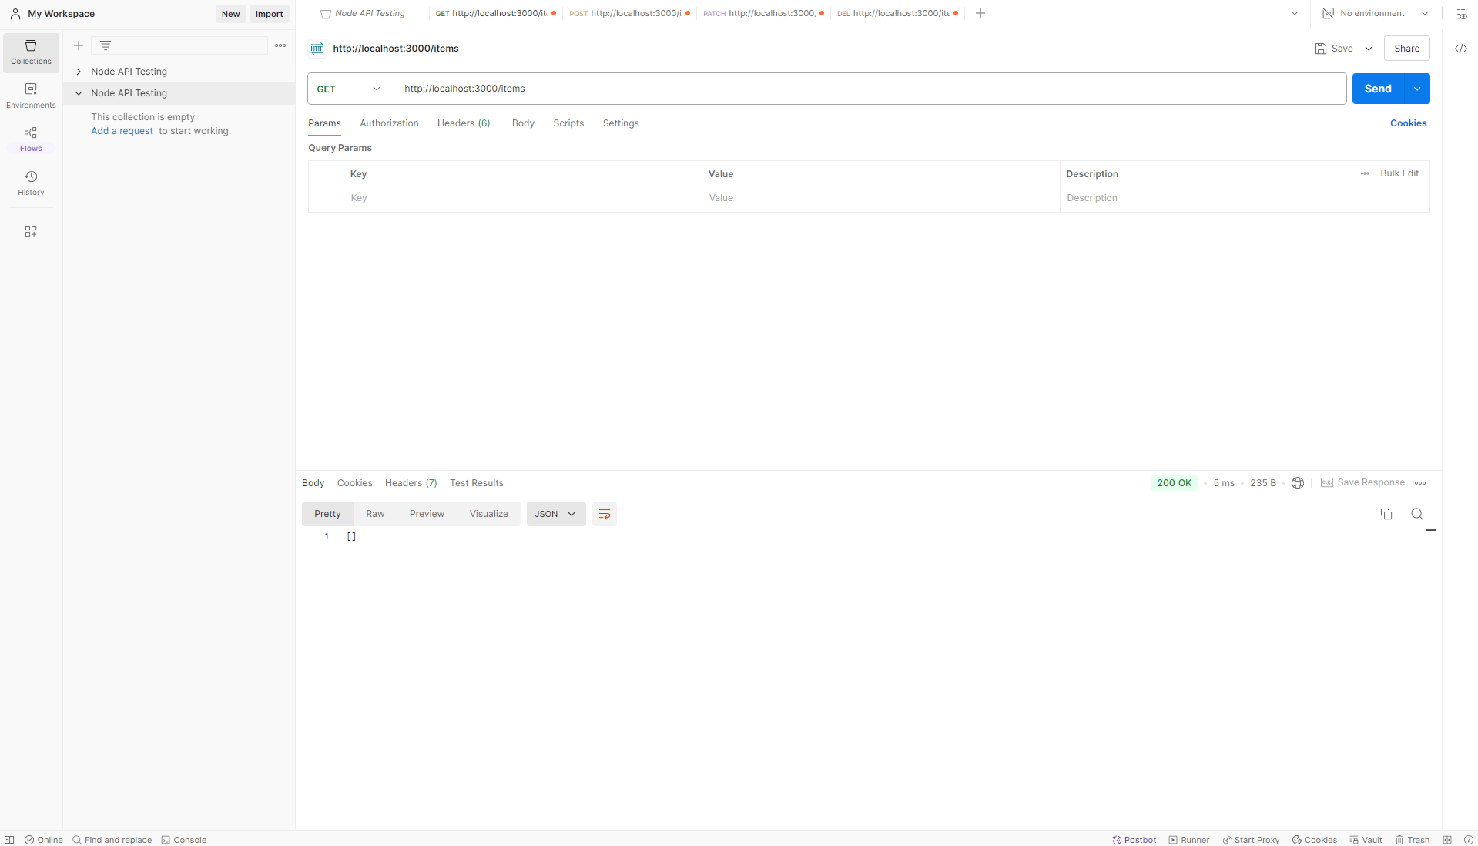

POST

PATCH

DELETE

